Configuration InfoGlue Calendar

- Roles controlling access rights
1
2
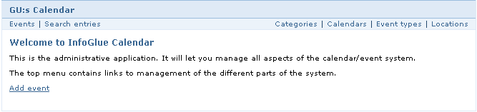
3

In the calendar application there are mainly three roles which controls access. They are:

- CalendarAdministrator – the users with this role in InfoGlue have access to the right part (marked with 2) of the menu which means they can administer system settings etc.
- CalendarOwner – the users with this role in InfoGlue have access to the left side (marked with 1) of the menu which means administrating events for the calendars they own. Which calendar a particular user owns is set up by the administrators under each calendar.
- EventPublisher – the users with this role in InfoGlue only has access to the “add event” option (marked with 3).

